Lamp project ---------🡪

1. Install apache
2. Install mysql-server
3. Install php
4. Configure apache to read new virtualhost
5. Provision ec2 instance
6. Login to AWS Console Management -----🡪 Search for EC2 ---🡪 Launch instances
7. Now instance is up and running.

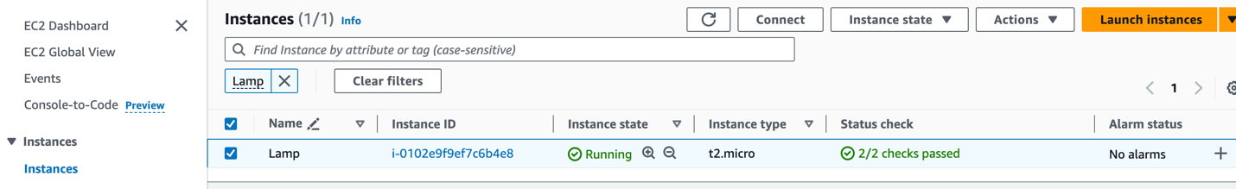

1. ssh to instance

ssh -i second-keypair.pem [ubuntu@ec2-54-210-173-69.compute-1.amazonaws.com](mailto:ubuntu@ec2-54-210-173-69.compute-1.amazonaws.com)

ssh -i path/to/key user@public_dns

or

ssh -i path/to/key user@public_ipv4

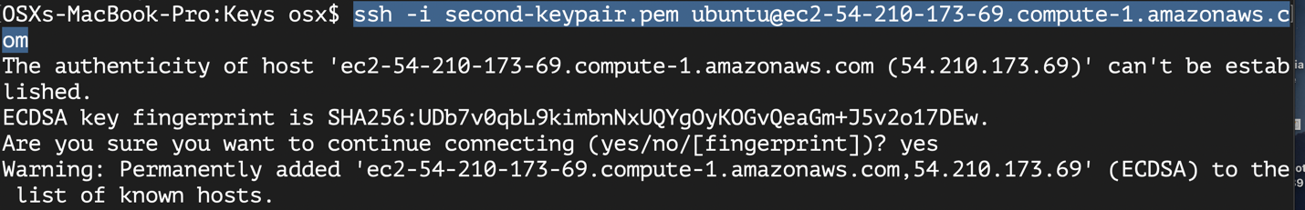

Security group must allow ssh to instance

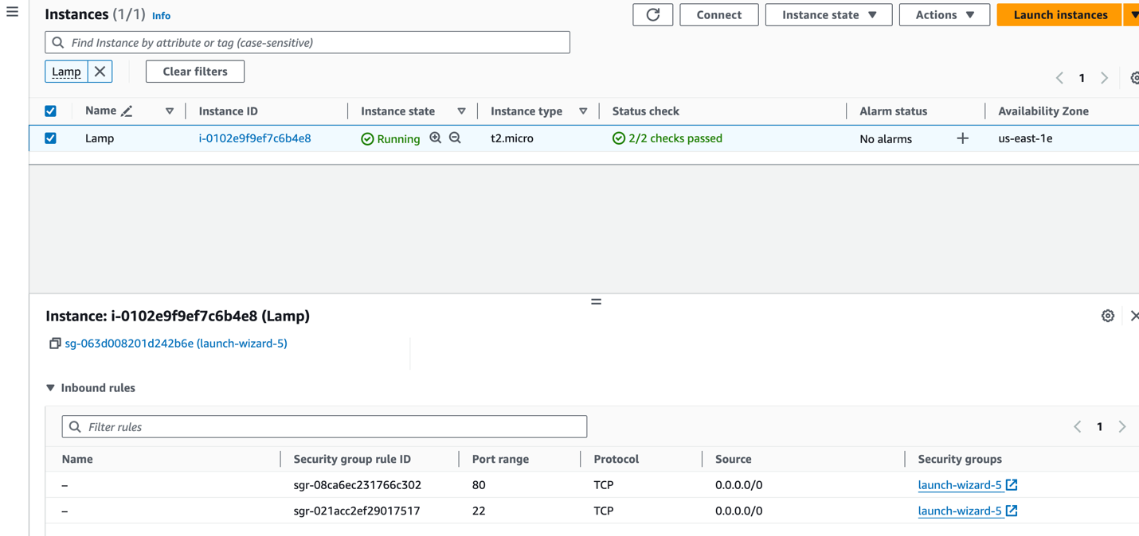

1. now update system then install apache

$ sudo apt update

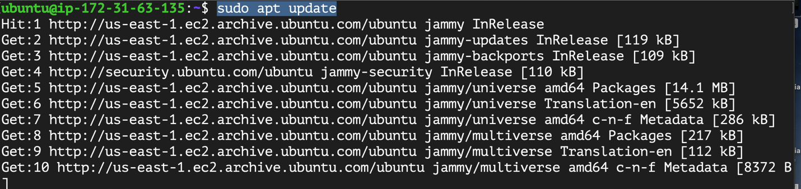

$ sudo apt install apache2

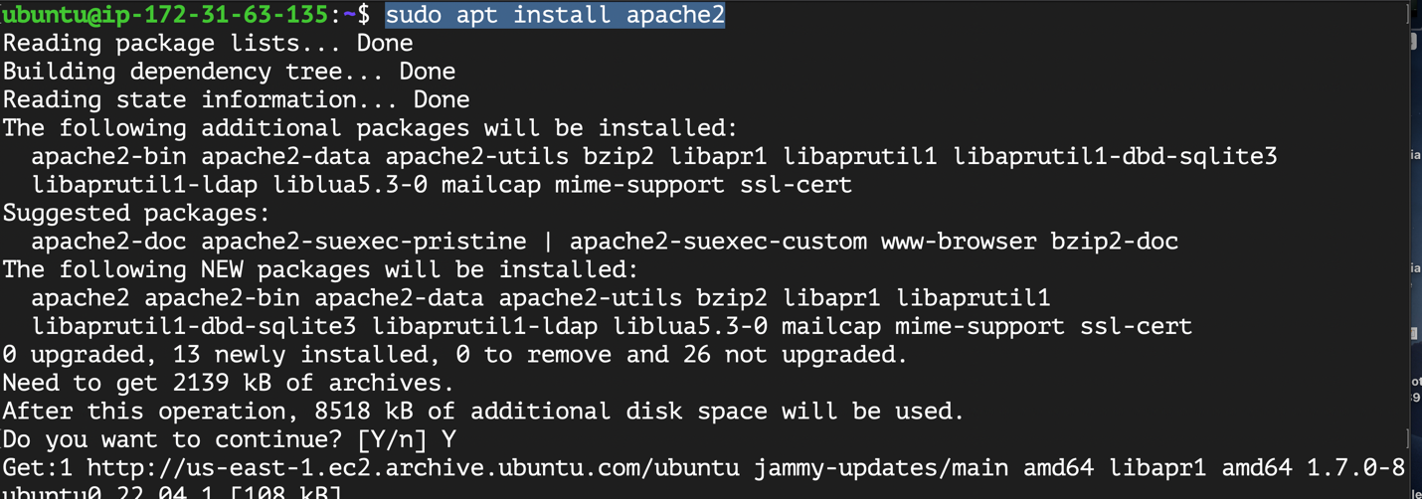

1. ensure that apache service is enabled and up && running

$ sudo apt install apache2

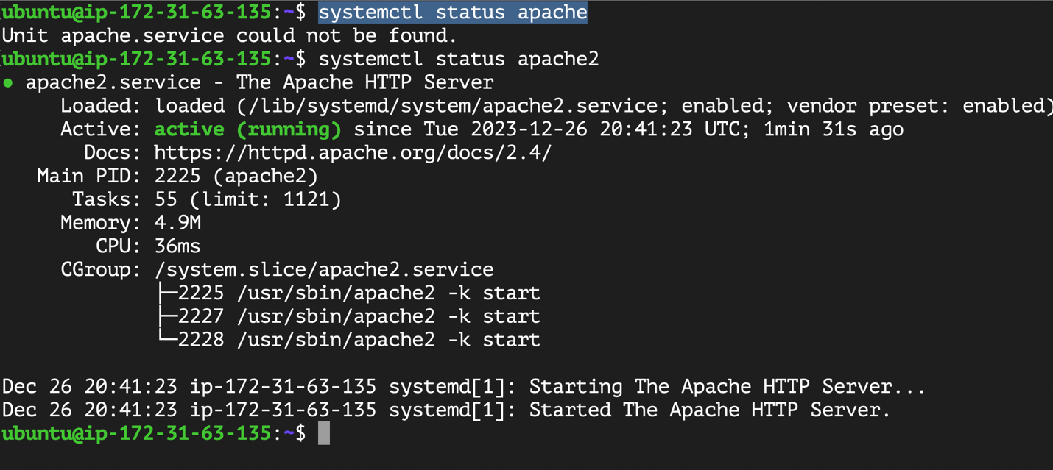

1. Now open browser and type public ipv4 of instance then enter

You should see default page for apache

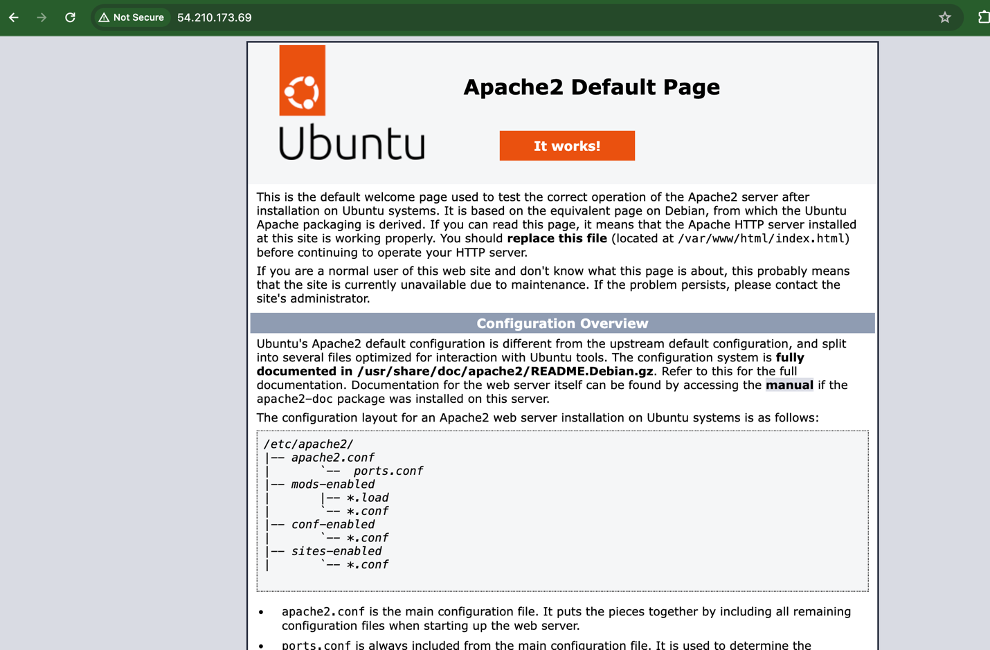

1. Install Mysql server

$ sudo apt install mysql-server

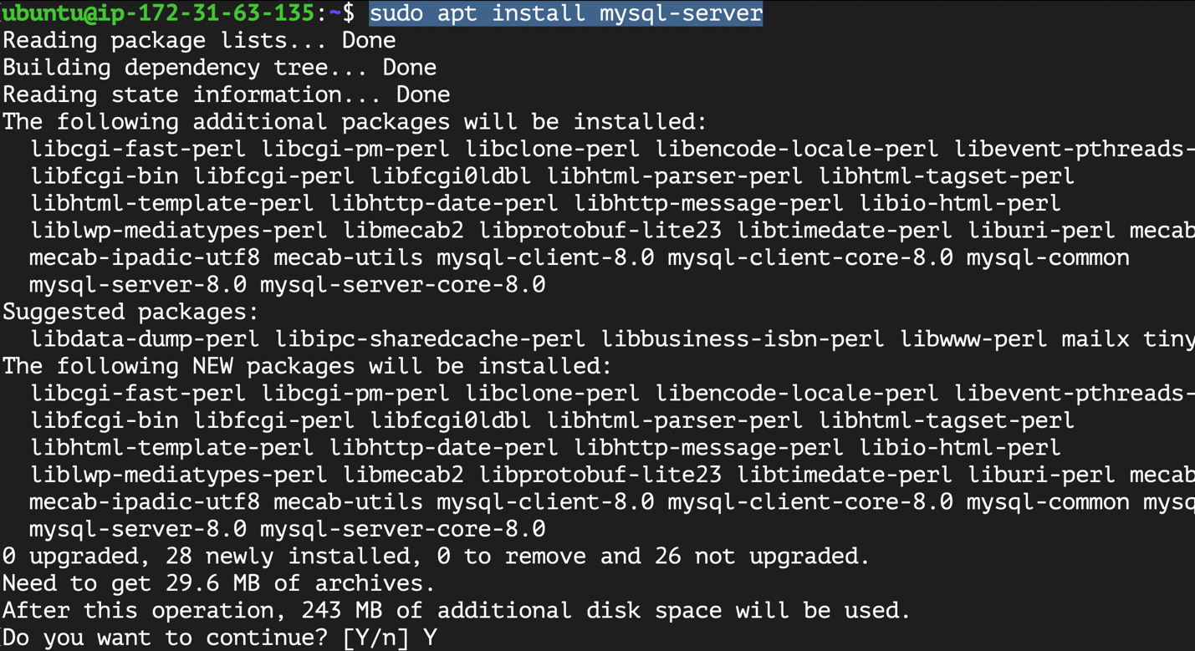

1. Connect to mysql server using root user

$sudo mysql

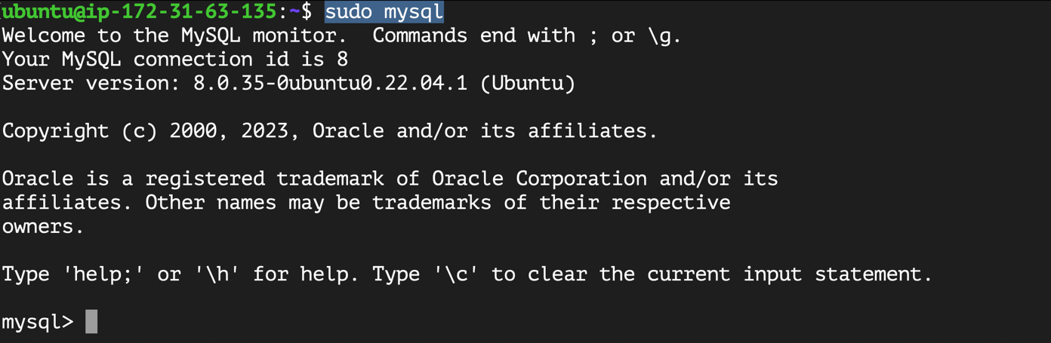

Change password for root user on mysql

1. Connect to mysql

sudo mysql

1. Change password for root

Alter user 'root'@'localhost' IDENTIFIED BY 'PASSW0rd.1';

-----------Syntax-----------

Alter user 'username'@'mysql-server' IDENTIFIED BY 'password';

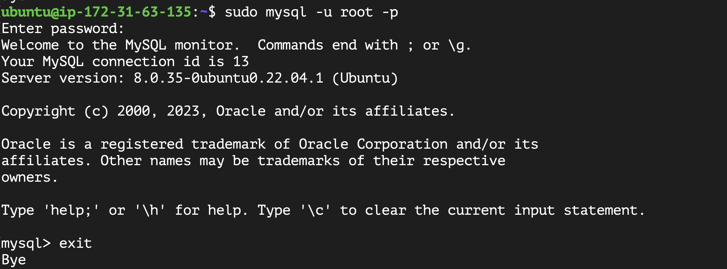

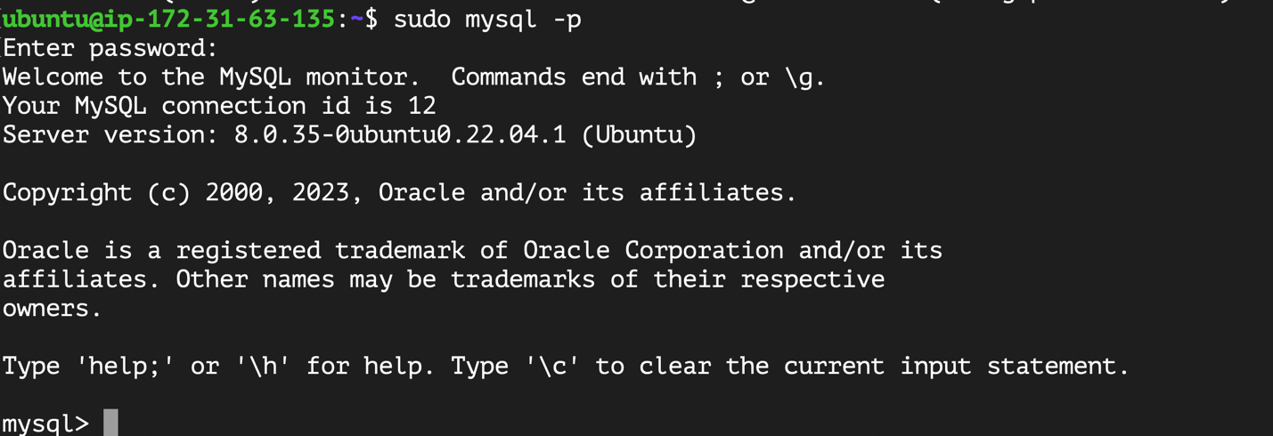

1. Now its time to overwrite default page of apache
2. Go to /var/www and create directory

$ cd /var/www

$ sudo mkdir LAMP_Project

1. Change ownership of this directory and nested files to current user logged on system ---{ ubuntu}

$ sudo chown $USER:$USER -R LAMP_Project/

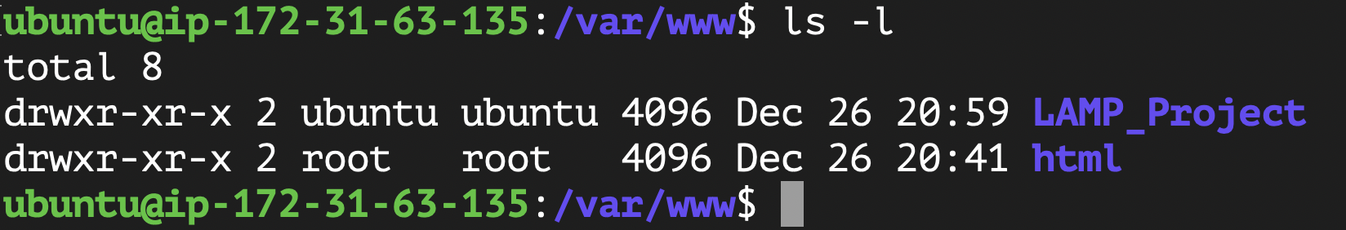

1. Go to /var/www/LAMP_Project create index.html file

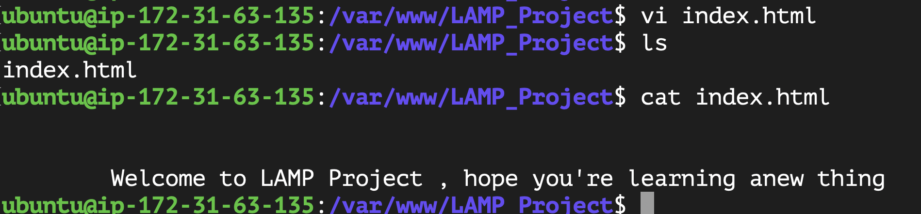

1. Now its time to make apache read its content from this location not default document root /var/www/html
2. Create configuration file

$ cd /etc/apache2/sites-available

sudo vi projectlamp.conf

<VirtualHost *:80>

ServerName lampproject

ServerAlias www.lampproject

serveradmin webmaster@localhost

DocumentRoot /var/www/**LAMP_Project**

ErrorLog ${APACHE_LOG_DIR}/error.log

CustomLog ${APACHE_LOG_DIR}/access.log combined

</VirtualHost>

1. Enable virtual host

sudo a2ensite lampproject

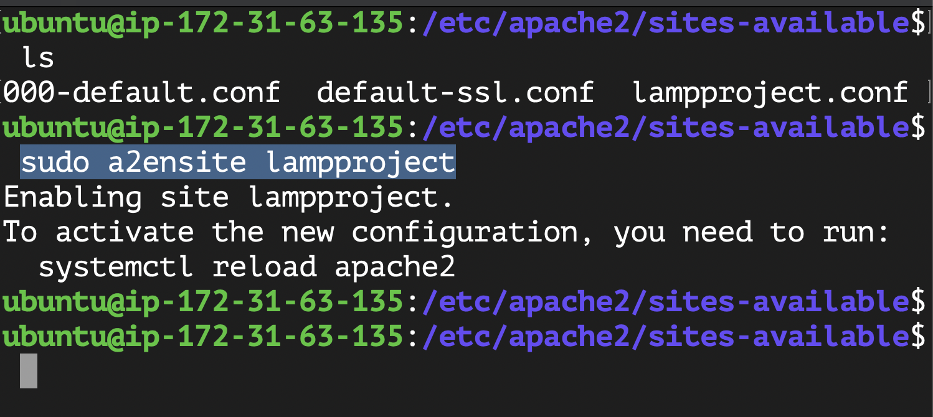

1. Disable default website

$ sudo a2dissite 000-default

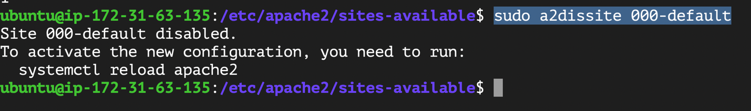

1. Test apache configuration

$ sudo apache2ctl configtest



1. Reload apache

$ sudo systemctl reload apache2



1. Install php

**$** sudo apt install php libapache2-mod-php php-mysql

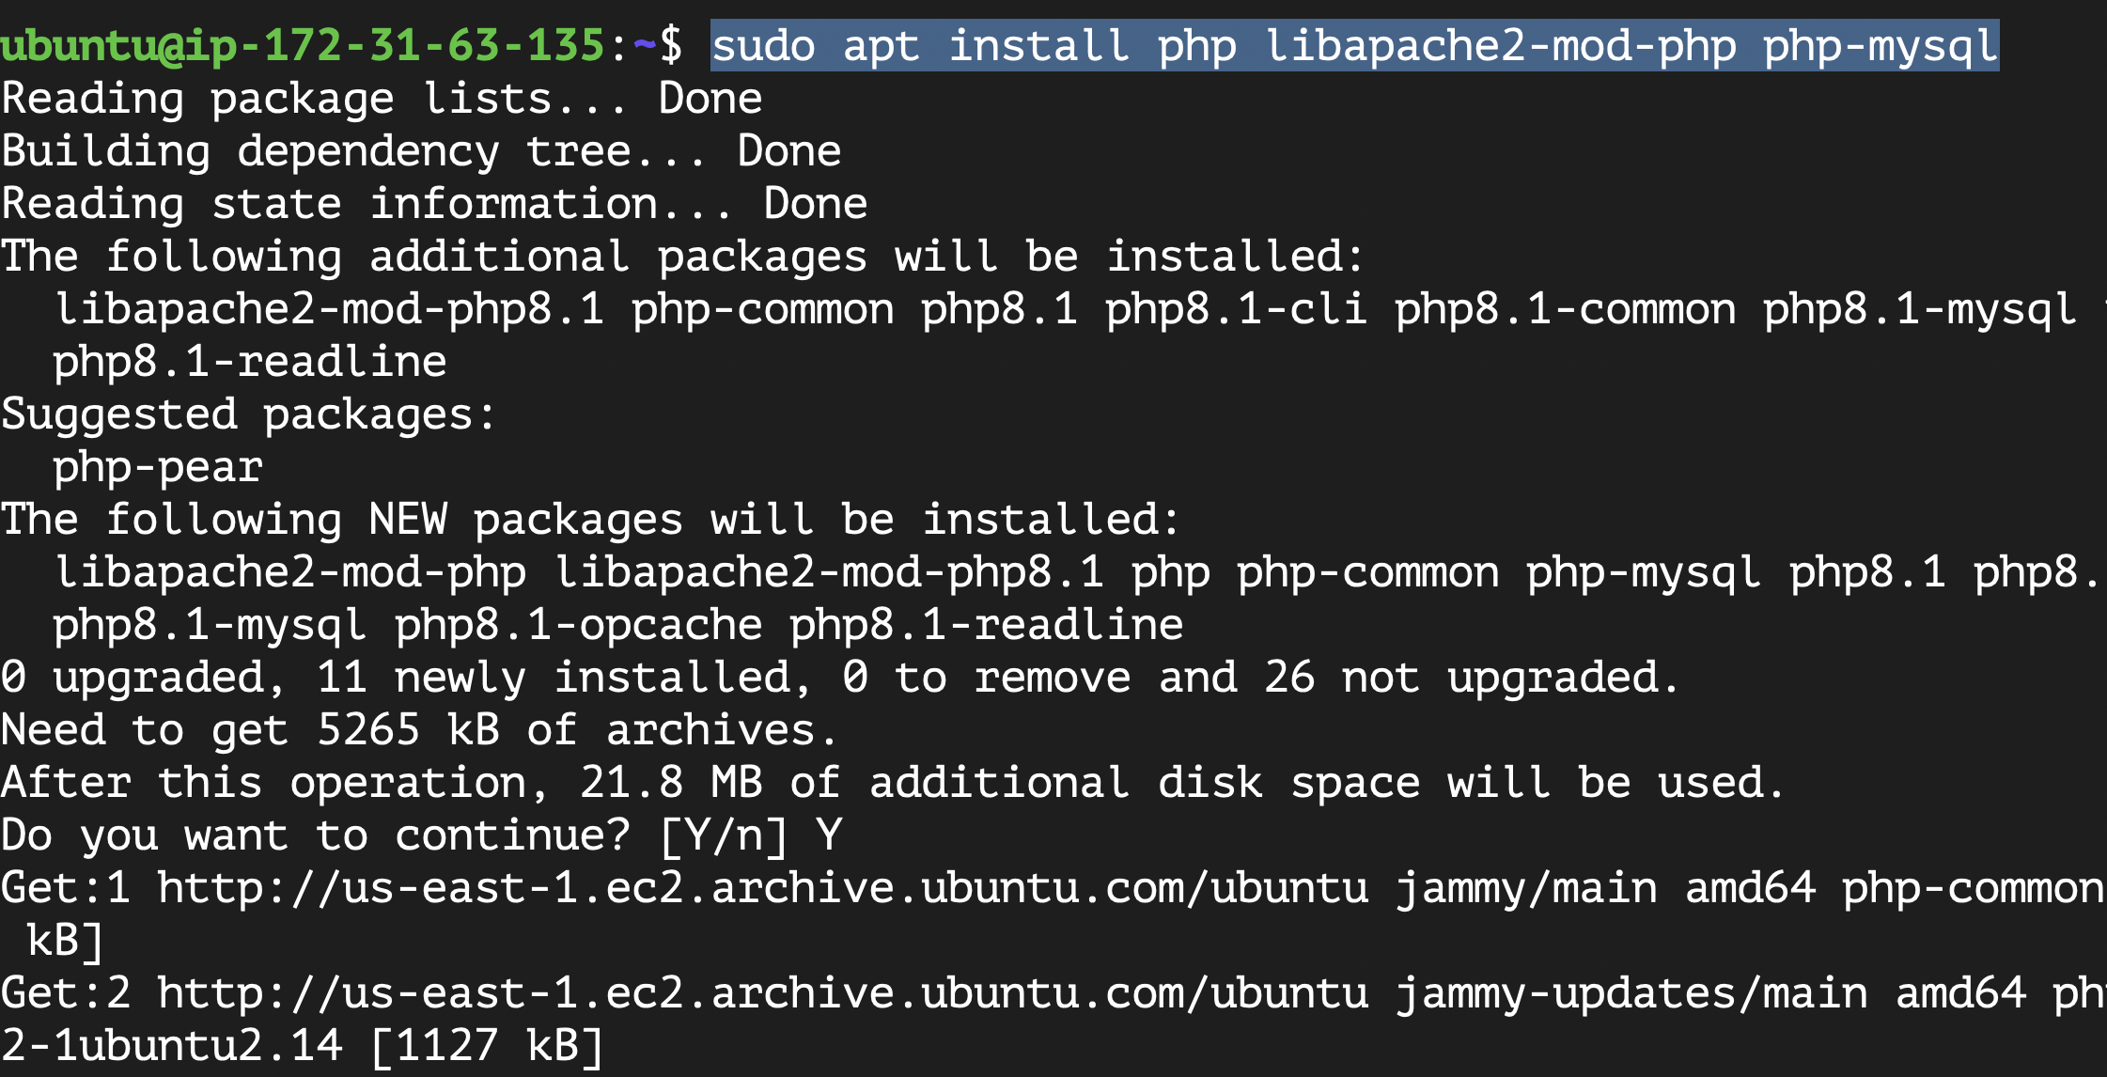

Ensure that php is installed

$ php -v

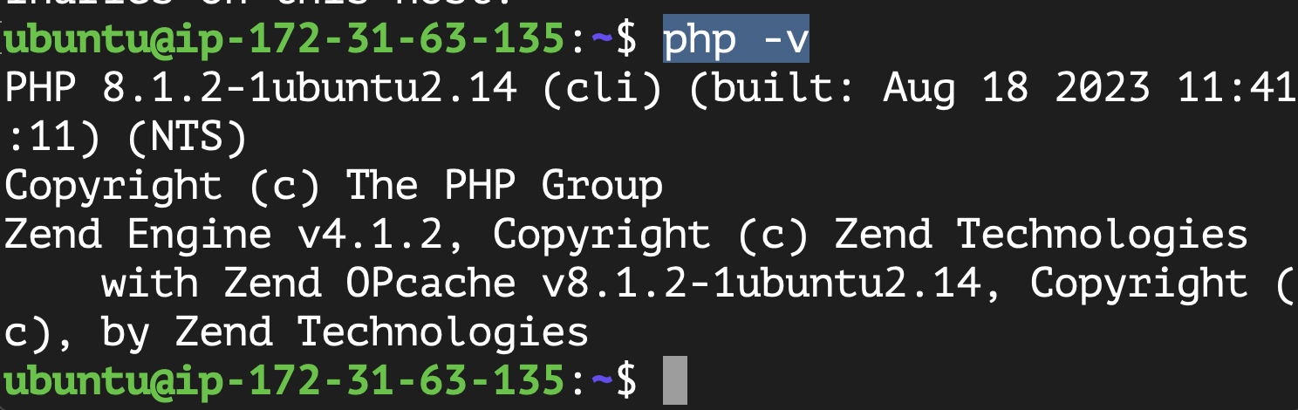

1. Last step we need to enable php on our website
2. We need to edit this file /etc/apache2/mods-enabled/dir.conf  and allow index.php
3. $ sudo vi /etc/apache2/mods-enabled/dir.conf

Add index.php after DirectoryIndex means that apache will search first on document root for file called index.php if not found search for index.html

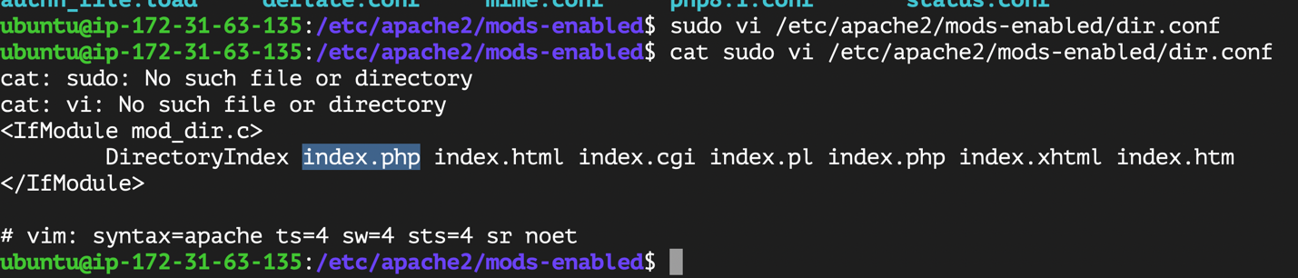

1. Go to /var/www/LAMP_Project and create index.php file

Write on this file

**<?php phpinfo(); save and close file**

1. Reload apache --🡪

$ sudo systemctl reload apache2

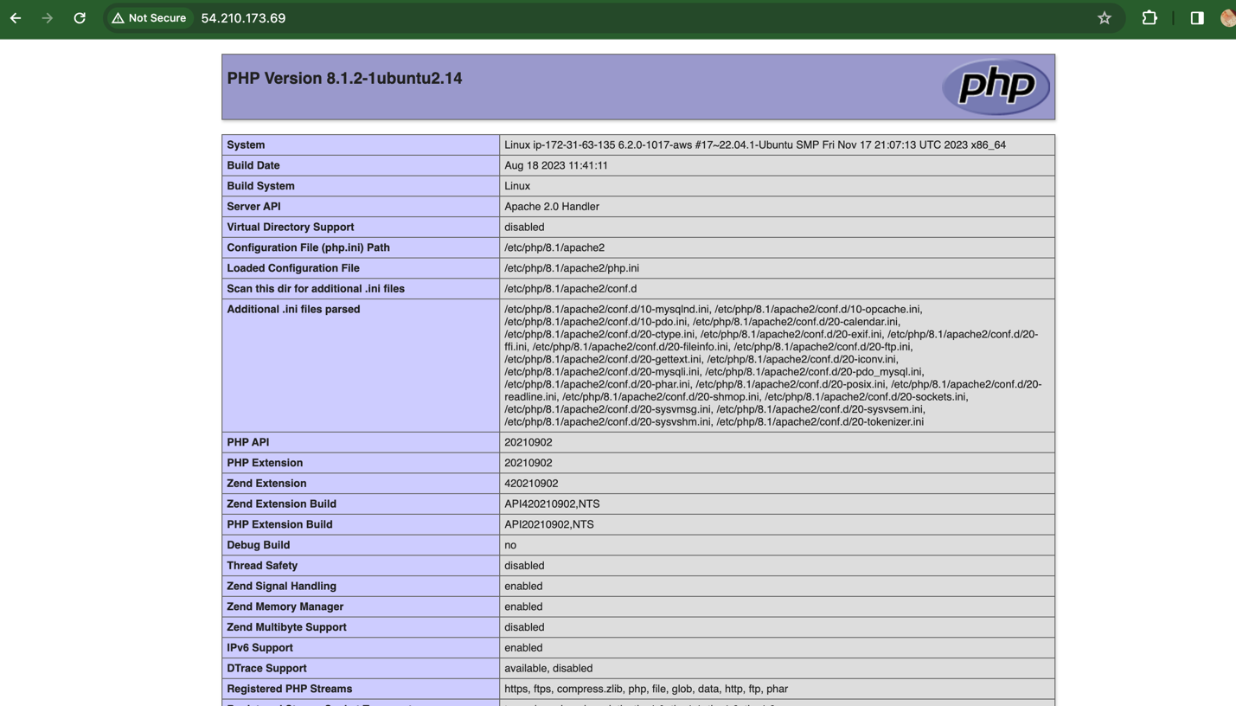

Serving website

Go to /var/www/LAMP_Project and clear folder

$ git clone <https://github.com/elmoatasem112/static-website-example.git>

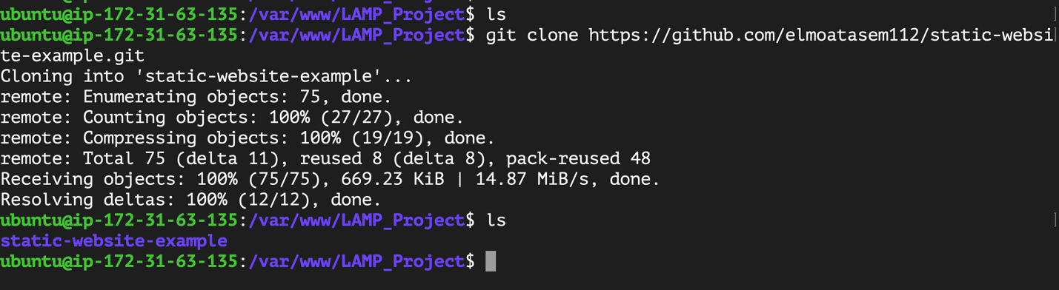

Now move content on static-website-example to LAMP_Project

$ mv LAMP_Project/* /home/ubuntu

Why ? Because apache document root serving from /var/www/LAMP_Project -🡪 then index.html

Not /var/www/LAMP_Project/static-website-example/index.html

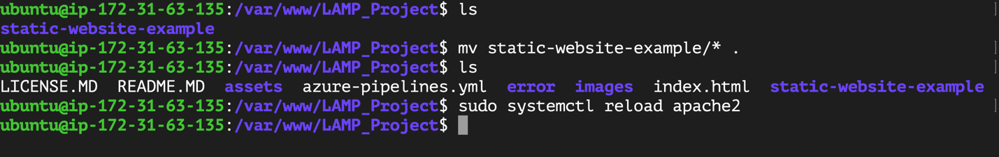

Access web site using public ip of ec2

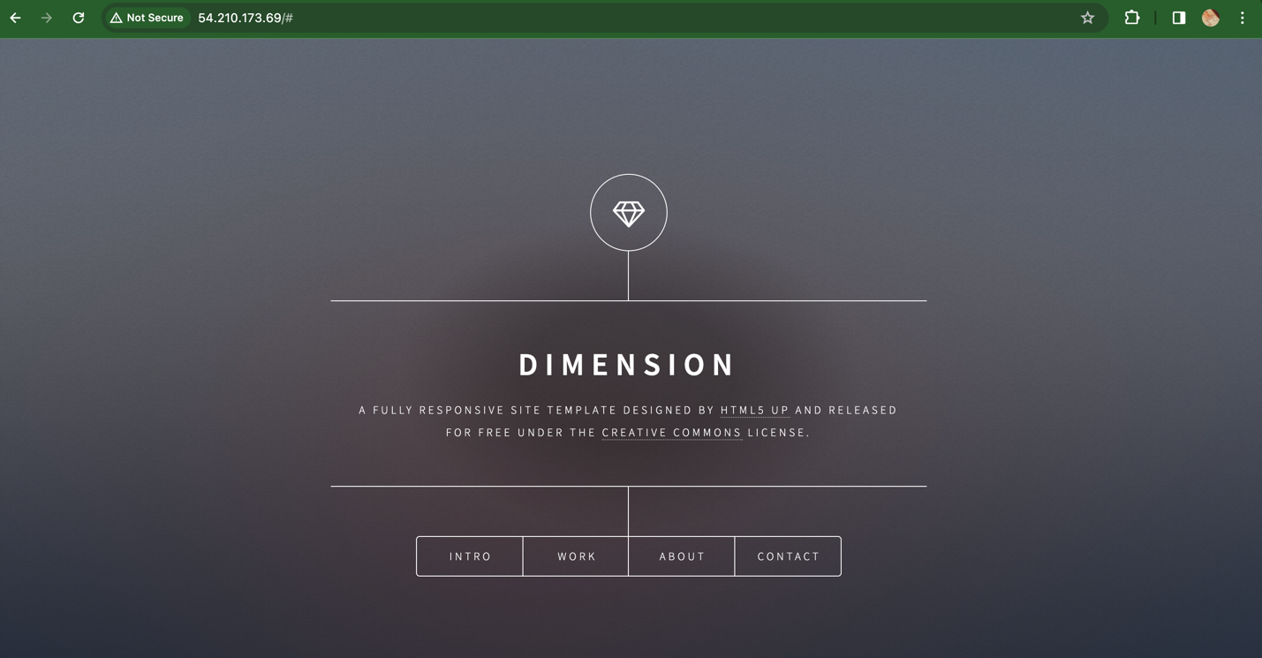

---------^^^^^^^^^^^^^Done^^^^^^^^^-------------------